Assignment 8.08: Conservation of Angular Momentum

- Angela is riding a bicycle and wishes to “pop a wheelie” in which she lifts the front wheel of the bicycle off of the ground. Pulling upward on the handlebars helps, but is not sufficient to keep the front wheel off the ground. What else should Angela do to raise the front wheel of her bicycle?

_____ Use the Front Brake _____ Use the Rear Brake _____ Pedal Harder
Use the Law of Conservation of Angular Momentum to explain your answer.

- A figure Skater is rotating at a rate of 1 turn per second. She has a moment of inertia of 150 kg m². She brings her arms and legs inward, causing her moment of inertia to drop to 50 kg m². What is her final rate of rotation?

- Betelgeuse is a Red Supergiant Star that is approximately 10 times more massive than our sun. According to astronomers, it is expected to go supernova, sometime in the next million years. At that time, most of the mass of Betelgeuse will be ejected into space and only the core of the star will remain. Betelgeuse currently has a radius of 8.213x10¹¹ m (approximately 5 times the radius of the earth's orbit around the sun), and rotates once every 30 days. After the supernova, Betelgeuse's core will have approximately 1/10 of its current mass, and have the same size as the Earth (r=6.371x10⁶ m) calculate the time it will take for Betelgeuse's core to rotate after the supernova. (You may assume Betelgeuse and its core fragment are both solid spheres with .)

- Explain the following comic in terms of the law of conservation of momentum:
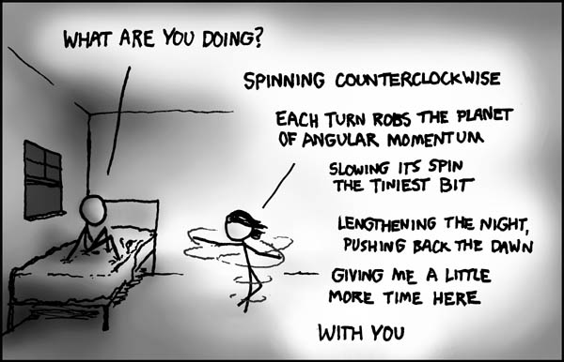

- The mass of the earth is 5.974 x 10²⁴ kilograms. Its radius is 6.387 x 10⁶ m. The moment of inertia for a solid sphere is given by . The earth rotates once every 24 hours.
  - What is the rotational velocity of the earth (in radians per second)?

  - What is the Moment of Inertia of the earth?

  - What is the rotational kinetic energy of the earth?

- The moon orbits the earth approximately once every 28 days. Its mass is 7.36 x 10²² kg, and its orbit is in the same direction as the earth's rotation. (The moment of inertia of any object that is orbiting another is given by I=mr²)
  - What is the orbital radius of the moon?

  - What is the total angular momentum of the earth-moon system?

  - The moon is moving away from the earth at 0.038 meters per year. How far will the moon be from the earth after 1 Billion years?

  - Use the law of conservation of angular momentum to calculate the length of a day on earth 1 billion years from now.

